Instructions for uploading your papers to Google Drive

For accessibility reasons, we are asking speakers to upload a copy of their paper into the conference Google Drive (see email for link).

Please aim to upload your file(s) at least 1 week in advance of your session, to allow other attendees time to read ahead.

You will need a Google account in order to do this.
If you do not have a Google account, please send your paper to:
Emma Crossey (woolfnotes@kcl.ac.uk) who will upload your paper on your behalf.

Instructions

Click the link (circulated by email) to access the Google Drive.
Find your panel (numbered as on schedule).
Please upload your paper with your name and clear presentation title.

Step by Step Instructions (with screenshots)

- Click on the link (circulated by email) to access the Google Drive.
You will see a list of folders – there is one folder for every panel.
- If you are not already signed in to your Google account, there will be a blue ‘sign in’ button on the top right. Click this and follow the instructions to sign into your Google account.
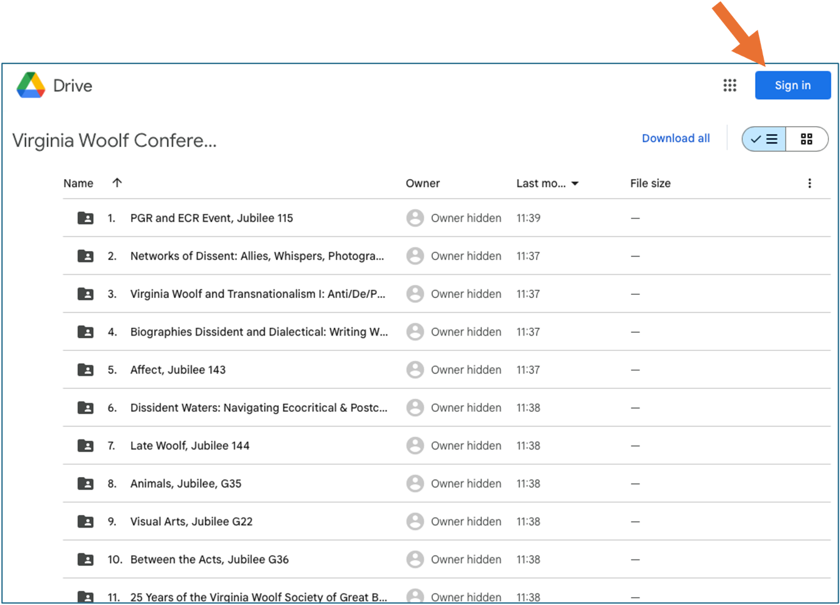
- When you are signed in, you will see the folder as follows:
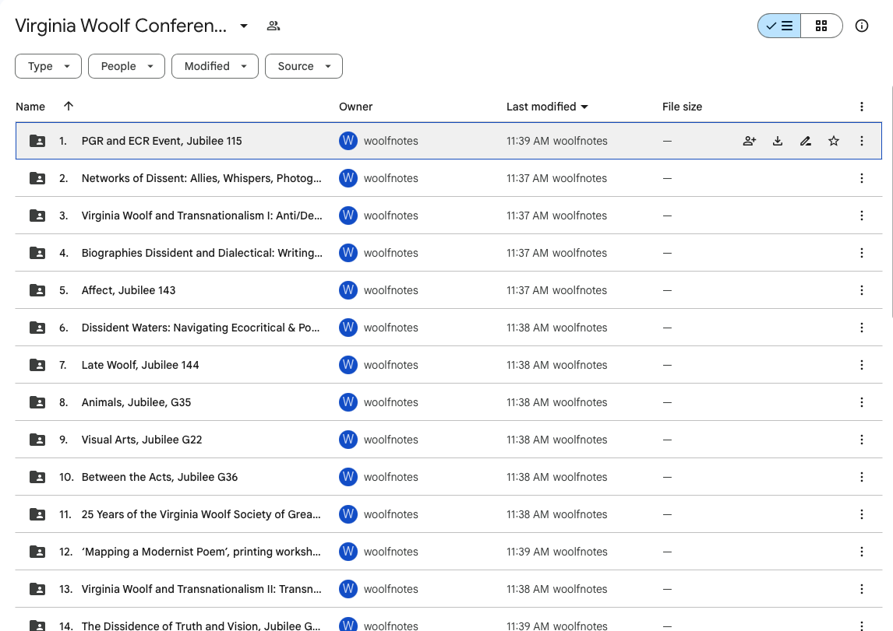

- Locate the folder named with your panel. Double click the name to enter the folder.

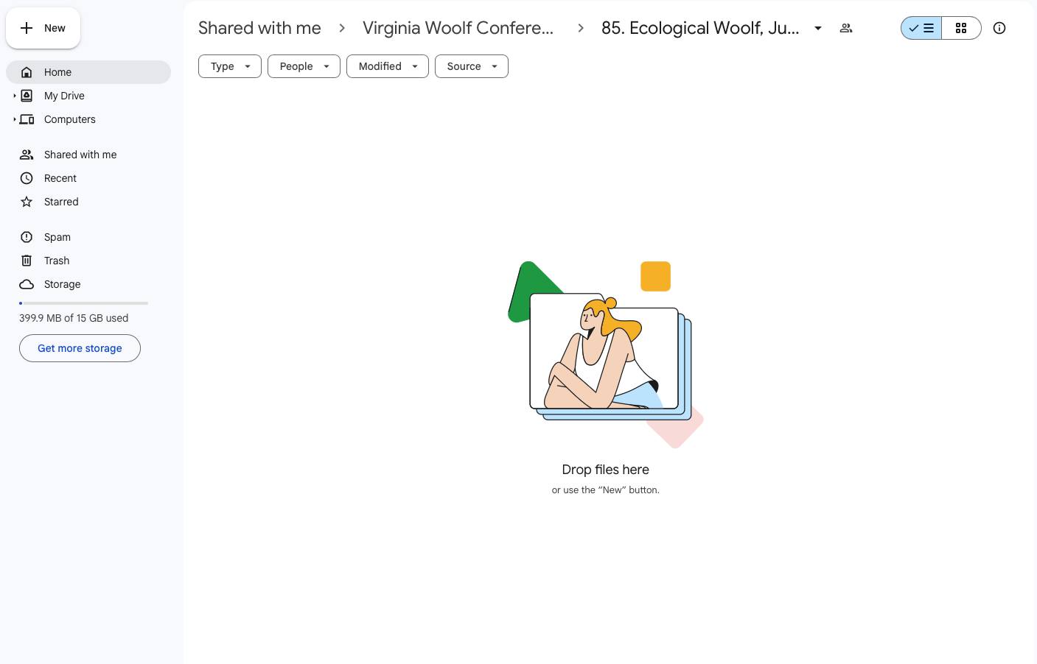
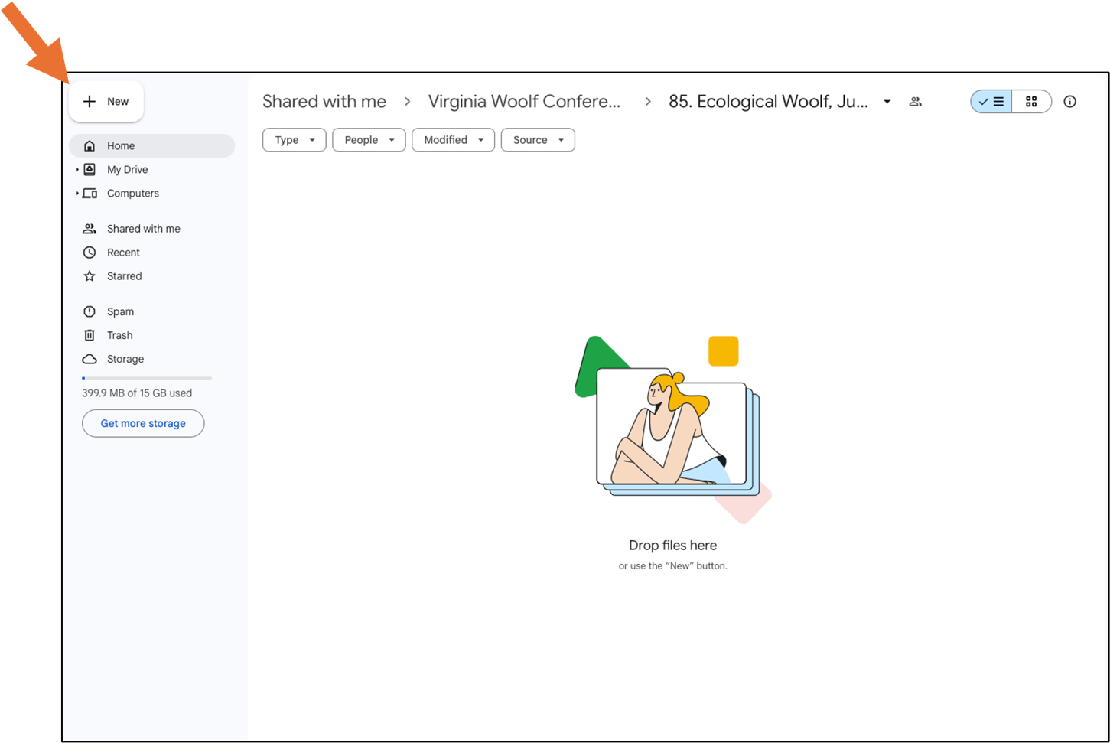
- Click ‘New’ (top left, above ‘Home’)

- Then click ‘File Upload’

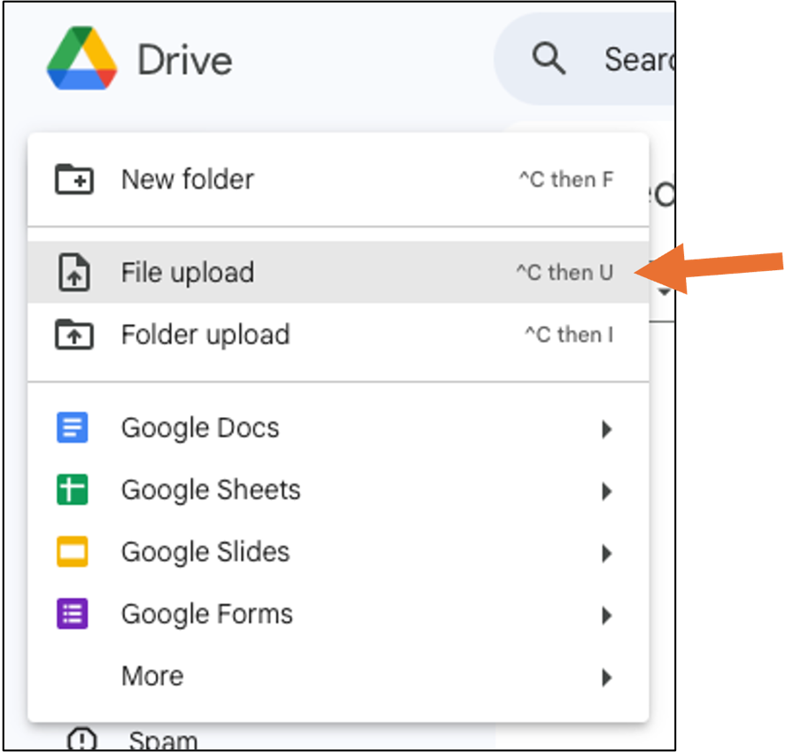

- Locate your paper on your own computer. Click your file and then click ‘upload’.
This screenshot may look slightly different depending on the type of your computer, but the process should remain the same.

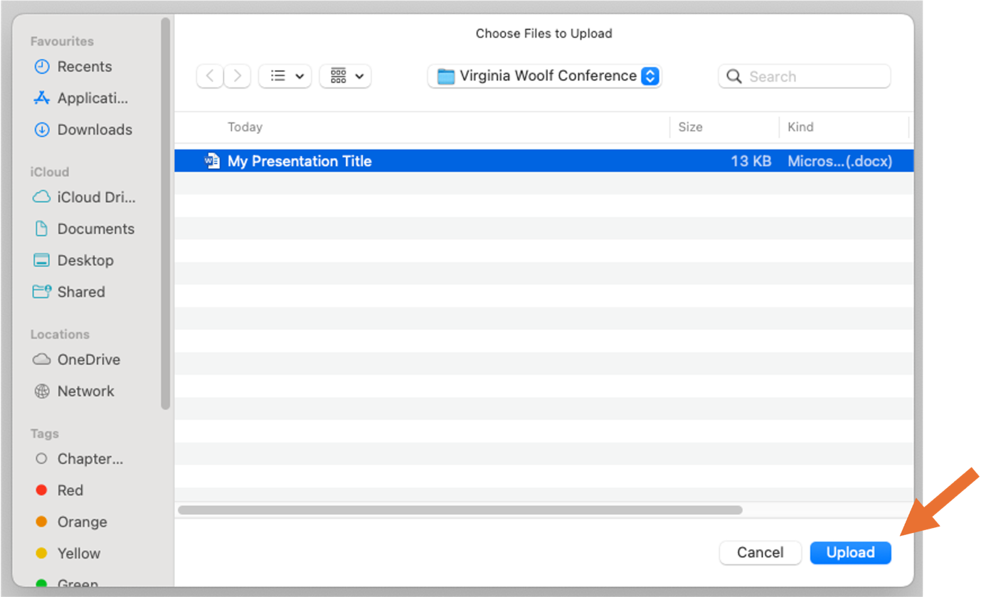

You are done! Your paper should appear in the folder.

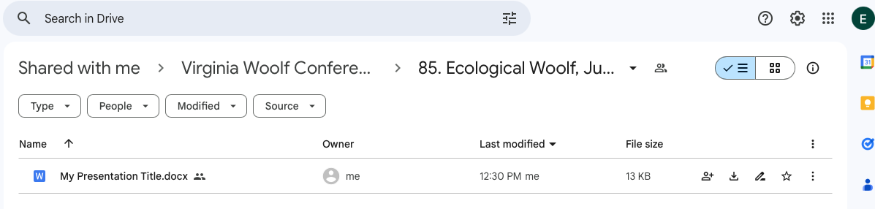

Any issues, please let me know. I can upload your paper for you if needed.

Contact Emma Crossey (woolfnotes@kcl.ac.uk)

